http://wantro.com/creative2/services/index.php
Remove “SERVICES” Heading and write “DEVELOPMENT”

Remove “DEVELOPMENT” heading from Image.
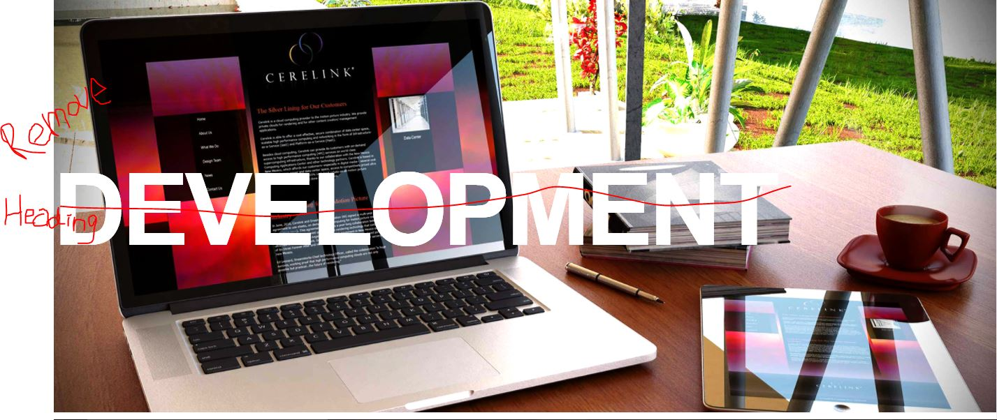

http://wantro.com/creative2/services/promotion-campaigning.php
Remove the text, its behind the image:

First Paragraph is missing:
And the heading “Why choose wantro……….” write above it
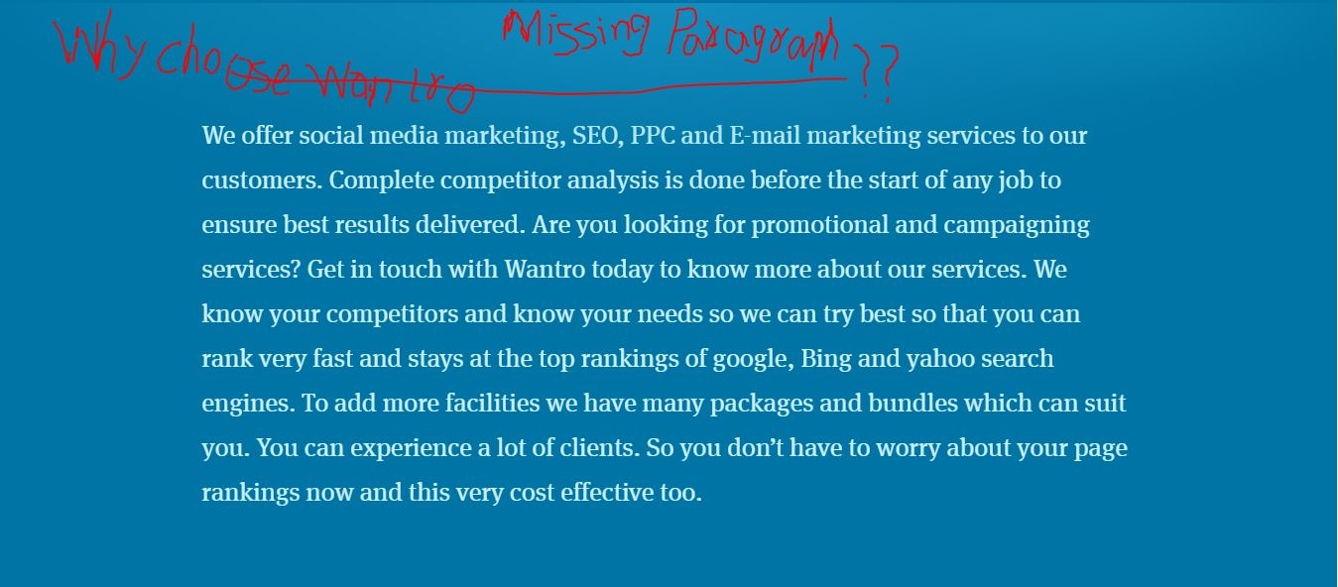

http://wantro.com/creative2/services/business-execution.php
Text is in Capital letters, write it in normal format:
